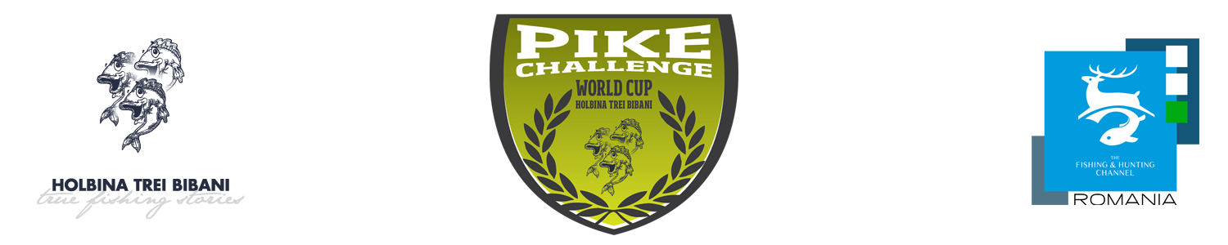

„PIKE CHALLENGE – World Cup - Danube Delta 2018”
Rules and Regulations
IVth Edition
May 18th – 20th 2018

These Rules and Regulations are supplemented with the Rules and Regulations on pike fishing competitions from boats, without a guide, on HTB premises and prevail it.
- The competition is organised as a „catch and release” fishing competition, from boats, with crews of 2 persons, on HTB premises – 1,270 ha.
- The competition runs in two rounds (Saturday 10 hours, 06:00 – 16:00 and Sunday, 6 hours, 6:00-12:00).
- Fishing is solely practised on the premises; fishing in the main channels and in access channels being prohibited. Trolling is prohibited.
- Upon entering the round, referees may check whether the organizer made the entire equipment available to the contestants.
- During the rounds, consumption of alcoholic drinks is prohibited and contestants are required, throughout the duration of the competition, to have a civilized and dignified behaviour both towards the other contestants and towards the referees, the HTB employees, the organizers and the sponsors.
- The proximity between two or more contestants, at a distance of less than 100 m, is solely allowed for medical emergencies (such as accidents, health problems) and will be immediately communicated to the Tournament Director.
- Technical failures of thermal/electric engines are reported to the Tournament Director, who will decide, as appropriate, whether technical assistance is necessary or whether engines have to be replaced during the competition rounds.
- Contestants are allowed to carry an unlimited amount of fishing rods in their boats during the fishing rounds, but each contestant will use one single fishing rod at a time.
- All types of artificial baits are permitted, except for artificial flies. The use of any kind of living or natural baits is prohibited during the competition.
- Contestants are allowed to return to the shore during the competition rounds only after having announced the Tournament Director and after having received his/her consent, except in the case of a medical emergency.
- Contestants are forbidden to exchange fishing equipment between crews and/or third parties during the competition rounds.
- The fishing net will always be used to bring the fish to the boat and the fish grip will be used in the boat to remove the hook.
- The minimum size of a catch to be scored is of 60 cm (1 point = 1 cm).
- Only live pike, having its physiological and motor functions within normal range (the fish is breathing, remains in its normal position without support and can swim) will be scored. After measurement, only fish capable of leaving the release location on their own will validated. It is the contestant’s responsibility to resuscitate the fish. The fish that is seriously injured or bleeding or which will obviously not survive after being released will not be scored.
- Measurements are made by the referees located in predetermined areas indicated on the map and the results will be announced during the technical meeting.
- Contestants may come to have their catch measured whenever they wish, but they will not bring more than 5 catches. If they bring more than 5 catches at a time to the referees, the latter will only take into account 5 catches and the crew will be immediately penalised 40 points.
- Fishing near referees at a distance of less than 100 meters from them is prohibited. The crew not complying with this provision is immediately sanctioned by the referees by warning and if this situation persists, that crew will be penalised 20 points.
- Fish measurements stop upon the expiration of the competition round, except for those already in progress. The referees are obliged to inform the Tournament Director of the crew number whose catch is being measured after the end of the round, as well as of the time when the measurement was completed. In this case, the time limit for the crew’s arrival to the finish line is extended with the duration communicated by the referees.
- Only the biggest 10 catches in the first round and 5 catches in the second round are scored. When summed up, they give the final ranking. In case of equal ranking, priority will be given to the largest catch. If the equal ranking still remains, priority will be given to the largest catch of each round.
- Fishing after the end of the competition round is prohibited. Non-compliance with this provision will result in the crew being disqualified from that round.
- Failure to comply with these Rules and Regulations will result in the contestants being sanctioned by the Referees or by the Tournament Director, as appropriate. Claims are settled by the Tournament Director or by the Organizer, as appropriate.

Organiser – HTB
